Unit IV(Linear Algebra)
Linear Transformation, Eigen Values and Eigen Vectors
Eigenvalues and Eigenvectors:

Definitions, Formulae and Theory
Eigenvalues & Eigenvectors

Let  be a matrix. Suppose the linear transformation 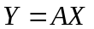 transforms  into a scalar multiple of itself i.e. 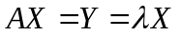 where is an invariant vector.
Then the unknown scalar is known as an eigenvalue of the matrix and the corresponding non-zero vector is known as eigenvector.
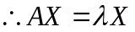 for any 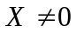
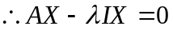
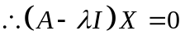
This represent a system of homogeneous equations in the variables.
It has a non-trivial solution if the coefficient matrix 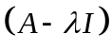 is singular.
i.e. 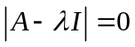
This is known as the characteristic equation of.
Expansion of the determinant gives a 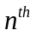 degree polynomial known as characteristic polynomial of.
Thus eigenvalues of matrix are the roots of the characteristic equation. Hence can have at least one and at most eigenvalues.
The eigenvector corresponding to an eigenvalue is obtained by solving the homogeneous system i.e.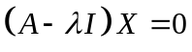 with this known eigenvalue.

Note 1: If all the eigenvalues of are distinct, then there correspond distinct linearly independent eigenvectors.
Note 2: For an eigenvalue of, repeated (twice or more), there may correspond one or several linearly independent eigenvectors. Thus the set of eigenvectors may or may not form a set of linearly independent vectors.
Note 3: Algebraic multiplicity of an eigenvalue is the order of the eigenvalue as a root of the characteristic polynomial. (i.e. If is a double root then algebraic multiplicity is 2).
Note 4: Geometric multiplicity of is the number of linearly independent eigenvectors corresponding to.
Note 5: Formula for finding characteristic equation of a 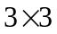 matrix

Note:
1. The eigenvalues of a real symmetric matrix are real. The eigenvalues of a real skew symmetric matrix are purely imaginary or zero.
2. The eigenvalues of an orthogonal matrix are real or complex conjugates in pairs and have absolute value 1.

Theorems on Eigen Values and Eigen Vectors:
- The eigen vectors corresponding to distinct eigen values of a real symmetric matrix are orthogonal.
- If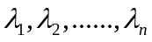 are eigen values of, then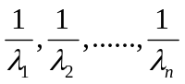are eigen values of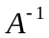.
- Ifis eigen value of non-singular matrix, then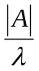 is eigen value of adjoint of.
- If is upper and lower triangular matrix, diagonal elements are eigen values of it.
- Any two eigen vectors corresponding to two distinct eigen values of a unitary matrix are orthogonal.
- If is an algebraic polynomial in andis an eigen value and is an corresponding eigen vector of a matrix then 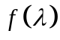is an eigen value and is an corresponding eigen vector of a matrix 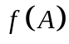.

Diagonalization of matrices

Similar Matrices
If and  are two square matrices of order n then is said to be a similar to if there exists a non-singular matrix  such that 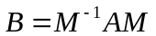.
A square matrix is said to be diagonalisable if it is similar to a diagonal matrix.
If  is an eigen value of the characteristic equation 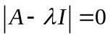 repeated t times then t is called algebraic multiplicity of . If s is the number of linearly independent eigen vectors corresponding to the eigen value then s is called geometric multiplicity of.
Note
- The necessary and sufficient condition of a square matrix to be similar to a diagonal matrix is that the geometric multiplicity of each of its eigen values coincides with the algebraic multiplicity.
- Every matrix whose eigen values are distinct is similar to a diagonal matrix.
- A square nonsingular matrix A whose eigen values are all distinct can be diagonalised by a similarity transformation 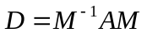 where M is the matrix whose columns are the eigen vectors of A and D is the diagonal matrix whose diagonal elements are the eigen values of A.

Cayley-Hamilton Theorem
Every square matrix satisfies its own characteristic equation; i.e. if the characteristic equation for the nth order square matrix is
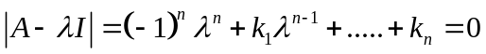 then
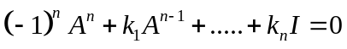 …..(i)
Note: To find 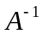 multiply both sides of (i) and simplify we get,
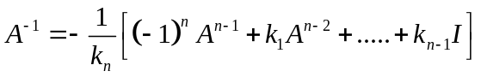
Quadratic Forms
Definition
A homogeneous polynomial of second degree in n variables is called a quadratic form..
For example
- 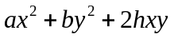 is a quadratic form in two variables.
- 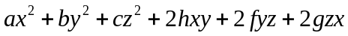 is a quadratic form in three variables.
- is a quadratic form in 4 variables.
Theorem: Every quadratic form can be expressed in matrix notation as 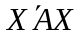 , where X is a column matrix, 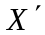 is its transpose and A is a square symmetric matrix of the same order as X.
Defn: If a quadratic form is expressed in matrix notation as where A is a square symmetric matrix, then A is called the matrix of the quadratic form.
The above quadratic forms can be expressed in matrix notation as
- 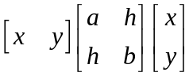
- 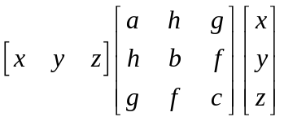
- 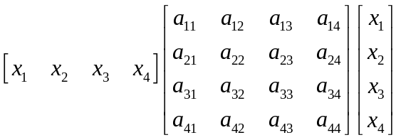
Linear Transformation:
Consider two sets of variables 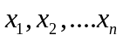 and 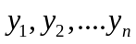. Let these variables be related by the following linear equations
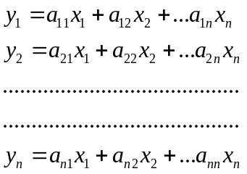
The above n equations can be expressed as a single matrix equation Y = AX
Where 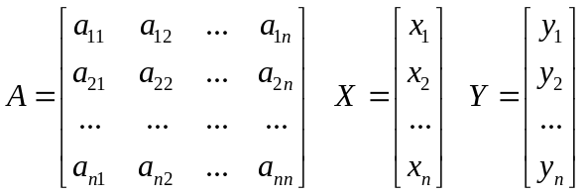
The transformation from y’s to x’s by the above equations is called a linear transformation. The linear transformation s singular or non singular according as the matrix A is singular or non singular.

Linear Transformation of a quadratic form:

Consider a quadratic form (where A is symmetric) and a non singular linear transformation given by X = PY
Now, 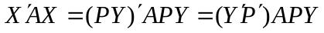
=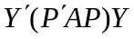
=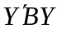 where 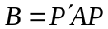
The quadratic form is called a linear transform of the quadratic form under X =PY.
Further, 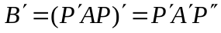
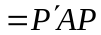 [since A is symmetric]
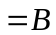
Hence, the matix B is also symmetric.

Congruence of quadratic forms:
Defn: Two quadratic forms and are said to be congruent if A and B are congruent i.e. if there exists a non singular square matrix P such that
Theorem: If is a quadratic form where A is a matrix of rank r then there exists a non singular linear transformation X=PY which transforms the given quadratic form to a sum of r square terms.
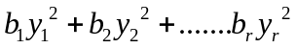

Canonical Form or Normal:
If A is a square symmetric non zero matrix of rank r then there exists a real non singular matrix P such that
Note: If is a quadratic form of rank r, then there exists a real non singular linear transformation X =PY which transform to
where B

Rank, Index, Signature:
- If a quadratic form by nonsingular linear congruent transformations X=PY is expressed as the sum or difference of squares of new r variables then the new expression is called the canonical form or Normal form of the given quadratic form, where r is the rank of the matrix.
- The number of positive squares is called the index of the quadratic form.
- The difference between the number of positive squares and the number of negative squares is called the signature of the quadratic form.
If there are in all r terms and s of them are positive there will be r-s negative terms and hence the difference between them = s-(r-s)
Signature=2s-r
Value Classes (Classification of Quadratic Forms)
A symmetric matrix A and the corresponding quadratic form are classified into five classes.
- Positive Definite
- Negative Definite
- Positive Semidefinite
- Negative Semidefinite
- Indefinite

